

DIGITAL ASSIGNMENT 2

|  |  |  |  |  |  |
| --- | --- | --- | --- | --- | --- |
| Programme | : | B.Tech. | Semester | : | Fall 2021–22 |
| Course Title | : | Calculus | DA | : | 2 |
|  |  |  |
| Register Number | : |  | Name | : |  |
| Faculty (s) | : | Jayagopal R | Date | : | 31 December 2021 |

Questions

1. Find the maximum and minimum values of 𝑓(𝑥, 𝑦, 𝑧) = 𝑥 − 2𝑦 + 5𝑧 on the sphere 𝑥 2 + 𝑦 2 + 𝑧 2 = 30.

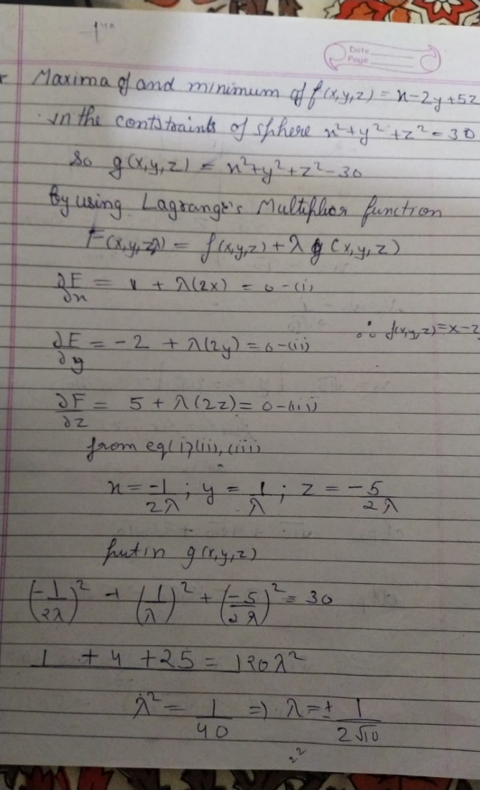

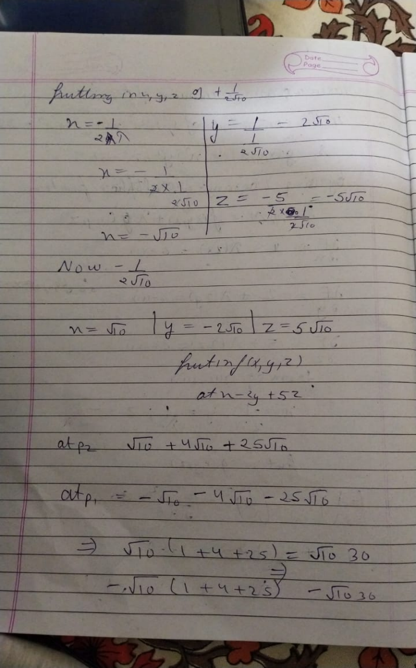

2: Evaluate the integral ∫ ∫ 𝑥 2𝑦𝑑𝑦𝑑𝑥 4−𝑥 𝑥2 2 2 0 by changing the order of integration.

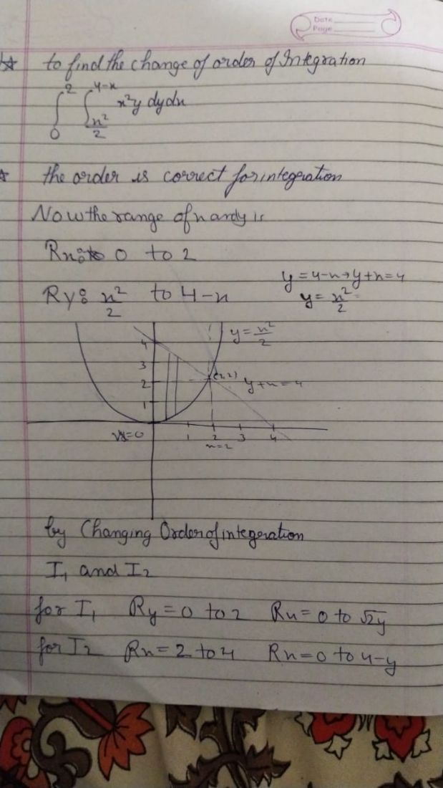

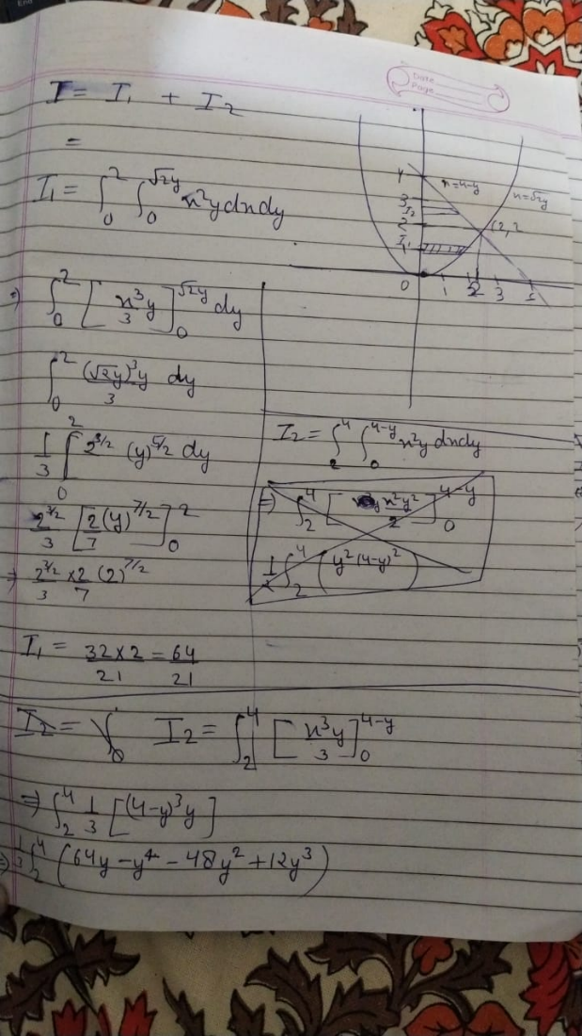

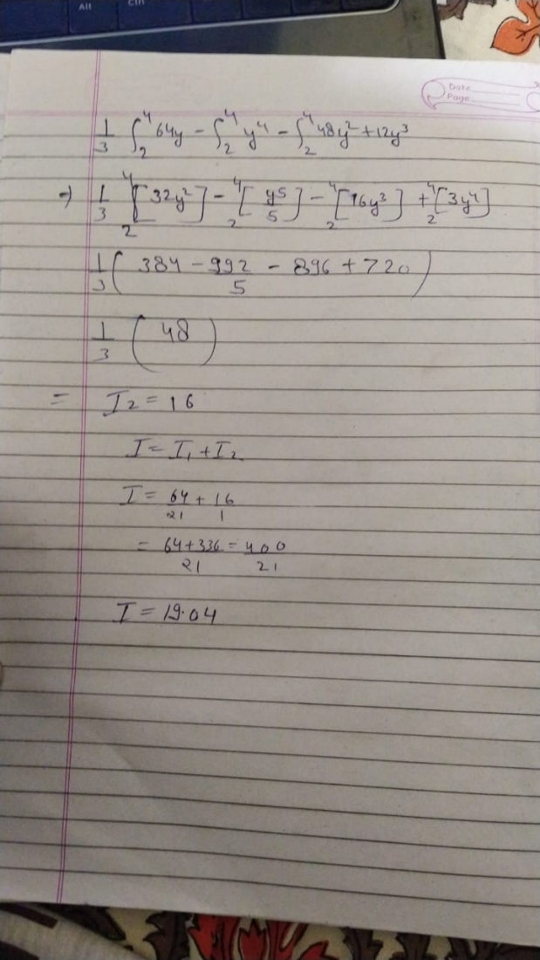

3: Evaluate the integral ∫ ∫ 𝑑𝑥𝑑𝑦 4+√16−𝑦2 4−√16−𝑦2 4 0 by changing the order of integration.

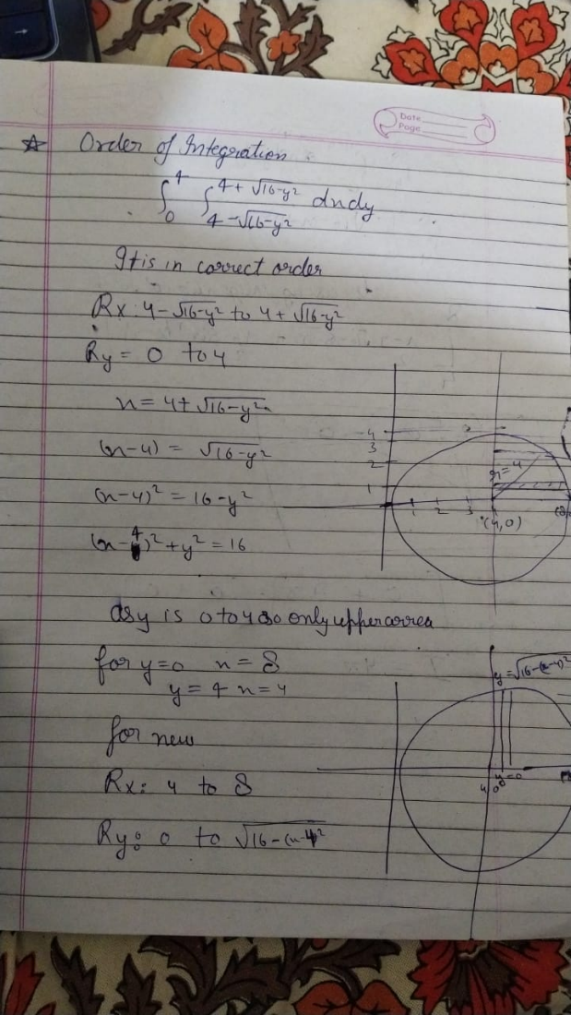

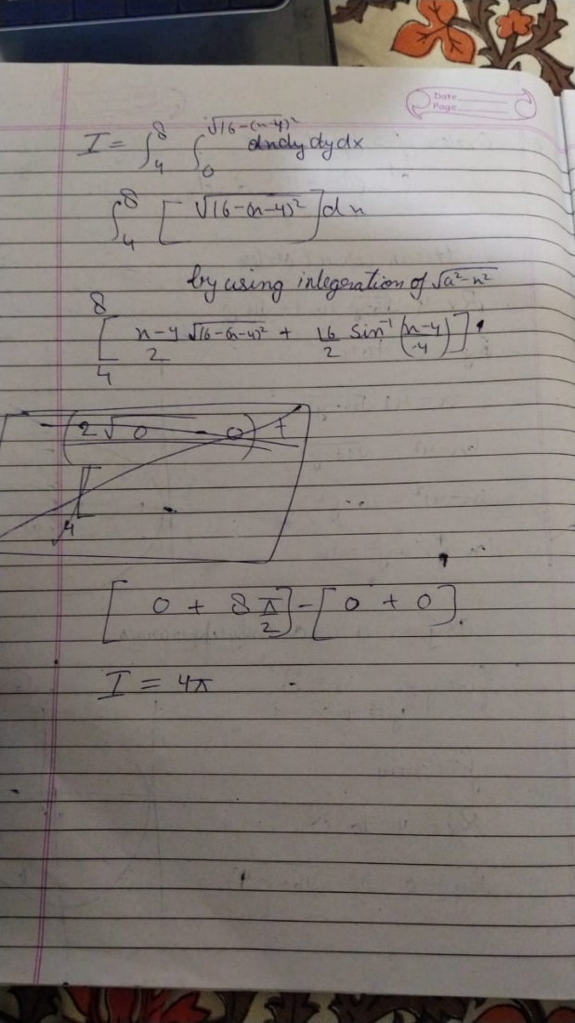

4: Evaluate the integral ∬ 𝑥 3𝑦 2𝑑𝑥𝑑𝑦 𝑅 by using betta and gamma function, where R is the region enclosed by the straight lines 𝑥 = 0, 𝑦 = 0 and 3𝑥 + 4𝑦 = 12 in the first quadrant without using the Dirichlet’s integral result.

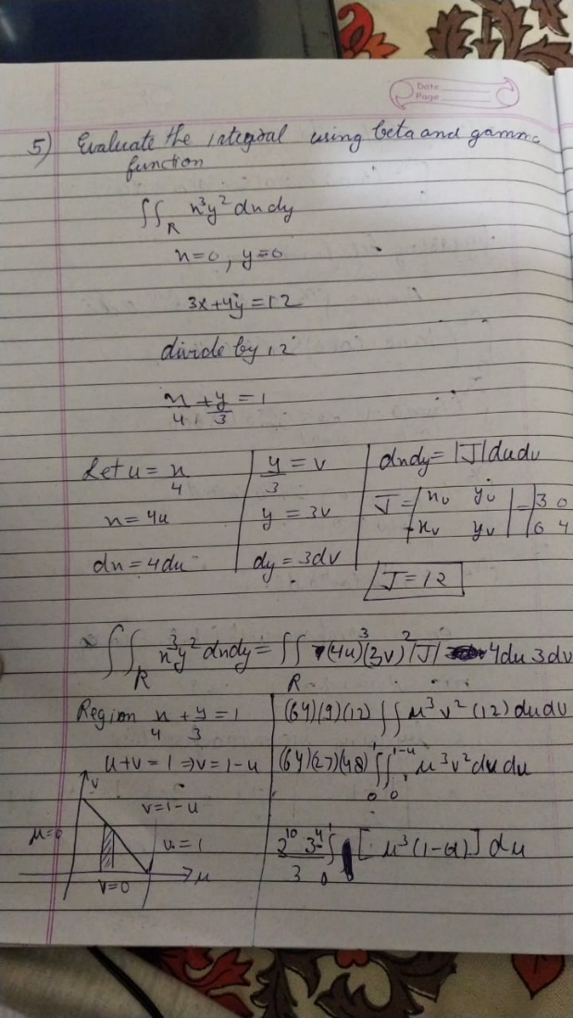

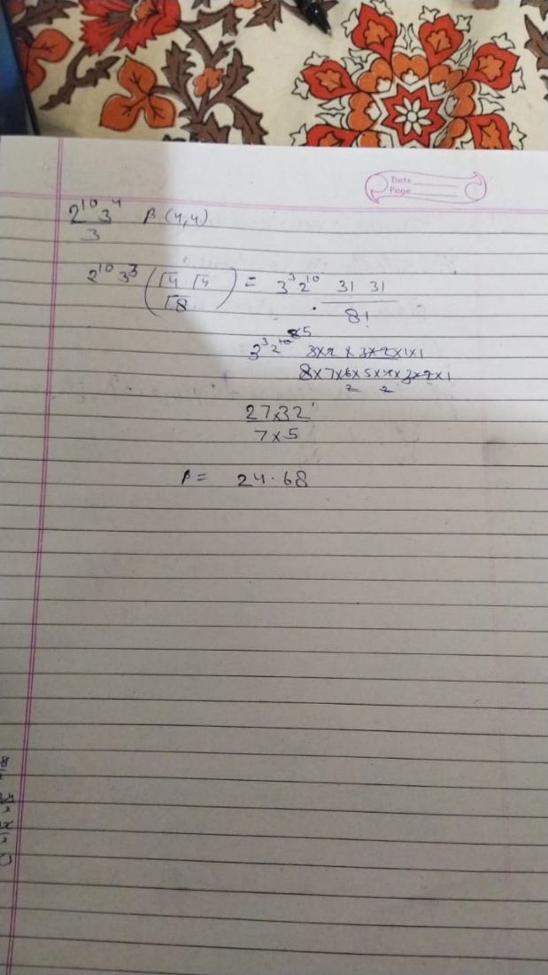

5 : Evaluate the integral ∫ (tan 𝜃 + cot 𝜃) sin5 𝜃 cos7 𝜃 𝑑𝜃 𝜋 2 0 by using betta and gamma function.

